Minutes of the Annual General Meeting

of the Junior Activities Sub Committee

held at Sawtell Surf Club on 14 March 2021

1. Meeting Open 1130am Chaired by Kel Pearce

**Members present:** Kel Pearce, Gerard Klinkers, Tiffany Easman, Alexandra Fraser, Joanne O’Leary, David O’Leary, Julie Dart, Monica Wordsworth, Amber Carle, Erin Powell, Russell Day, John Wing, Julia Doust, Andy Doust, Mark Mullholland, Andy Manning, Deb Reinholdtsen, Carney Peters, Lyn Hastings, Anthea Martin, Rich McKeon

2. **Record of Apologies**: Sheena McTackett, Anita Williams

3. **Confirmation of Voting Rights.** Chair confirmed voting rights of members.

4. **Confirm Minutes of Previous Meeting.** Moved Joanne O'Leary/seconded Monica Wordsworth

5. **Business rising from Previous Minutes.** Nil.

6. **Presidents Report.** Gerard Klinkers read his report. A copy is attached to these minutes.

7. **Treasurer's Report.** Report attached.

8. **Other reports.** Nil.

9. **Election of New Committee Members.** The following members were elected unopposed to the following JASC positions:

* **Chairperson** – Tiffany Easman (Nominated Gerard Klinkers /seconded David O’Leary)
* **Vice Chair** – Rich McKeon (Nominated Jo O’Leary /seconded Tiffany Easman)
* **Secretary** – Anita Williams (Nominated Tiffany Easman /seconded Jo O’Leary)
* **Treasurer** - Jo O'Leary (Nominated Tiffany Easman/seconded Rich McKeon)
* **Registrar** – Alex Fraser (Nominated Rich McKeon /seconded Tiffany Easman)
* **Beach Superintendent** – David O’Leary (Nominated Tiffany Easman/seconded Jo O’Leary)
* **Water Safety Coordinator –** Andy Manning (Nominated Tiffany Easman /seconded Jo O’Leary)
* **Publicity** vacant
* **Sponsorship** – vacant
* **Gear and Maintenance Officer** – David O’Leary (Nominated Andy Manning/seconded Tiffany Easman)
* **Gear and Maintenance Officer** – Garth Lewis (Nominated Andy Manning/seconded Tiffany Easman)
* **Gear and Maintenance Officer** – Mark Mullholland (Nominated Andy Manning/seconded Tiffany Easman)
* **Competition Manager** – vacant
* **Clothing Coordinator** – Jane Ryan (Nominated Tiffany Easman/seconded Gerard Klinkers)
* **Social Coordinator** - vacant
* **Awards Coordinator** - vacant

The following members elected to fill the following *Age Manager* positions:

* **U6AM**: Kate Wood
* **U7AM**: Russ Day
* **U8AM**: Julia Doust, Naomi Little, Taren
* **U9AM**: Erin Powell, Andy Manning, Amber Carle
* **U10AM**: Tiffany Easman, Andrew Doust, Shaun Powell
* **U11AM**: Rich McKeon, Caroline Dunphy, Carney Peters, Jody Jenkins
* **U12AM**: Matt Ryan, Bob Aspden
* **U13AM**: Mark Mullholland, Becc Wark
* **U14AM**: Andrew Martin, Julie Dart, Jo O'Leary
* **Inclusion AM**: Lyn Hastings, Sheena McTackett

10. **Thank you to Previous Committee Members.**

Kel Pearce thanked the Committee and members for their efforts and commitment, and congratulated the JASC for their work during the 2020/2021 season. It was acknowledged that Nippers led the way in terms of Covid preparation, furthermore, there was great representation at surf sports carnivals at all levels. It was also noted the importance of ensuring there are succession plans in place.

11. **Notices of Motion.** Nil

12. **Urgent General Business.**

Comments from the Senior Committee included an acknowledgement of the significance of the importance of the Nippers program in Sawtell and as future lifesavers. It was also noted that the Nippers have a great brand in the community.

13. **Meeting Closed**: 1158am

**JASC Chairpersons Annual Report 2020/2021**

Despite of the global COVID-19 pandemic, the Sawtell SLSC Junior Activities Sub - Committee (JASC) has had a successful season with our members.

With a ‘safety first’ approach we developed a COVID Safety Plan before start of the Season, setting out how we could deliver the Nipper program during the 2020-21 season. We are very pleased that we have been able to offer our usual variety of activities including regular Sunday Nippers, board and surf training sessions and competing in three North Coast Branch carnivals and NSW State Championships in Swansea-Belmont/Redhead. Unfortunately, due to COVID-19 restrictions, for the first time in 20 years the pre-season Manly LSC camp was unable to go ahead. The North Coast Branch cancelled participation to the NSW Interbranch Championships and the Branch also had to cancel the North Coast Branch Under 14’s development camp. A big disappointment for all Country Surf life saving Clubs was the cancellation of the NSW Country Championships, scheduled for February 2021 in Kingscliff. We are hoping that all these cancelled events will be able to run again in the next season!

In my role I have witnessed so many people being involved in our surf club in different ways, not all visible to everyone, but all important. It is not possible to thank everyone individually in this report, so if your name is not mentioned please accept this message as a heartfelt **thank you** for your contribution this season, whether it was as trainer, coach, age manager, water safety, official, branch carnival organiser, IRB crew, trailer towers, BBQ crew, setting up/packing up beach, or in any other role.

I would like to acknowledge the **sponsors** of our Nippers for this season: Coffs Coast First National Real Estate, GJ Gardner Homes, RJK Optometry, BCU, Split Café & Espresso Bar, Bakers Delight Toormina and HQ Concrete. Your commitment enables us to continue offering this opportunity to our members: thank you very much for your generous support.

***Nippers program and education***

Nippers is an Australia wide program where kids become surf aware and may become patrolling members once they get their Surf Rescue Certificate. Every age group has an age specific skills program, which is our guide for Sunday Nippers. This is where the U6-U14 **Team of** **Age Managers** come in: they have been fantastic this season and were able to engage with Nippers and parents in a COVID safe and fun way. Thank you all for your commitment, patience and great work with the Nippers!

Once again I would also like to thank Andrew Martin (Chief Training Officer) for his tremendous commitment to prepare our most senior Nipper group of U14’s for their Surf Rescue Certificate (SRC).

All younger age groups have also achieved awards involving Surf awareness and beach safety, basic rescue and first aid techniques, as well as beach environmental protection. Sportsmanship, healthy participation and encouragement of other club members continue to be encouraged in our activities. We also congratulate the parents who have achieved their SRC/Bronze Medallion.

***Competition***

This season had 156 registered Nippers, which was more than 10% more than the previous few years.

As mentioned before the Competition in Surf life-saving has been affected by COVID-19. Credit goes to all those involved in the North Coast Branch who managed to coordinate and run three carnivals during this season, in the new and successful ‘block racing format. Our Club had great participation at these three carnivals in the **North Coast Branch** (twice in Woolgoolga and in Minnie Water).

A group of 12 dedicated JASC competitors participated in the **NSW State Age Championships** in Swansea-Belmont/Redhead. Congratulations to all Nippers who competed against the best in the State, with many excellent individual and team results. At the time of writing this report no info was confirmed whether any U14s will be competing at the scheduled Aussies on the Sunshine Coast in Queensland in April.

***Special mention***

In this COVID affected year I like to specially mention the incredible commitment from our **fantastic** **coaching team**, coordinated and delivered by Greg Russell. David O’Leary, who has been looking after the beginner group and Joanne O’Leary/Shane Golden have trained the advanced short boarders, while Kevin Clancy delivered flags & sprint training.

Congratulations to two of our U14’s: Arla Aspden and Angus Waugh for winning the Sawtell SLSC ‘**Junior Lifesaver of the Year**’ Award. Arla and Angus represented Sawtell SLSC at North Coast Branch level. They both participated admirably and are a credit to this club, and their families.

A few more highlights of this season to mention include our annual Santa visit plus BBQ, our new range of beautiful t-shirts and polo’s, the Club’s and the presentation.

I would especially like to acknowledge and thank our **Junior** **Committee** for the huge commitment all year to make sure all is running as smoothly as possible, especially in this ‘COVID year’. Our uniform shop has done an amazing job with great new clothing and good sales! Financially we are very healthy. We have set-up a great communication system through several communication channels. And we have invested in some new quality boards and equipment for our youngest Nippers.

Thank you all for being part of Sawtell Nippers in the 2020/21 season. I also hope to see some new parents getting involved next season in our great club: there are many jobs to do and be active with your kids!

I would like to finish this report with a personal note. After 15 years of involvement in Sawtell Nippers, through my 3 kids (Mette, Finn and Ella) I will ‘graduate’ from this great movement. ‘Nippers’ has brought my kids and myself so many great memories and experiences and I am proud to have been involved for that many years. Thank you for having me in various roles at Sawtell Nippers!

We hope this Season has brought you many great memories and we look forward to seeing you all back in September at the registration for the **next season of Sawtell Nippers**. Go Sawtell!

*Gerard Klinkers*

*Junior Activities Sub Committee Chairperson, Sawtell SLSC*

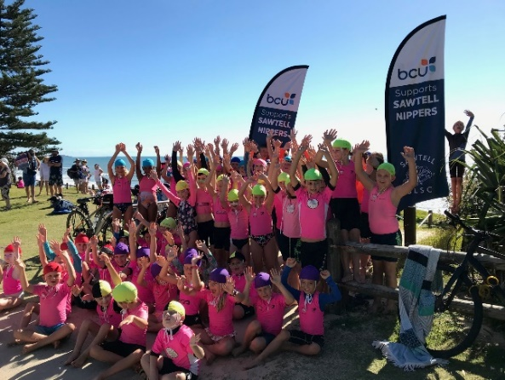 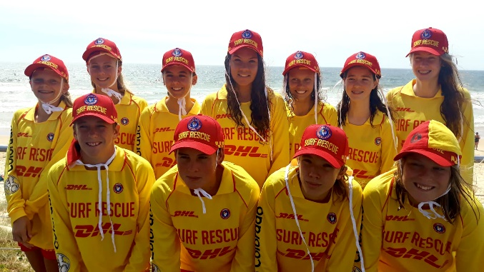

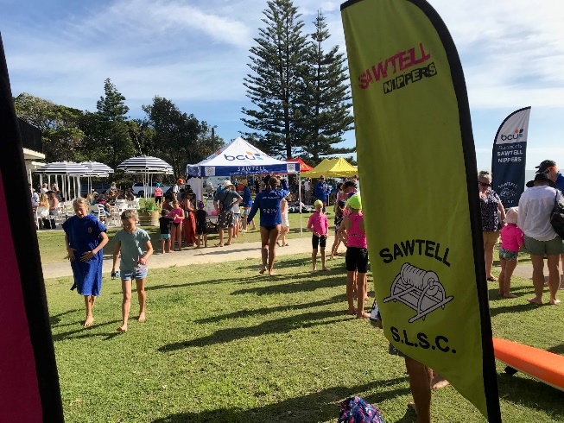 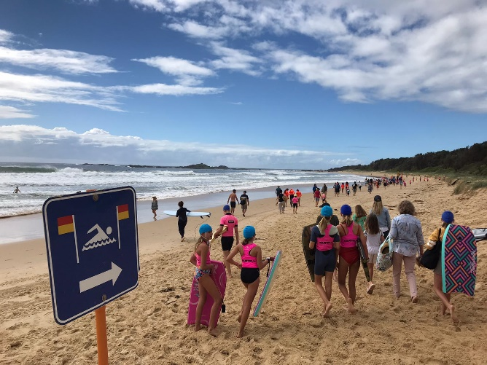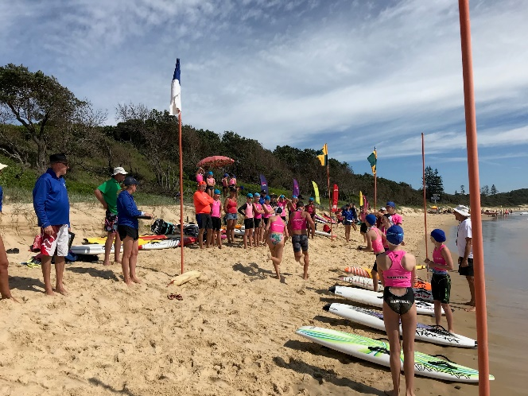 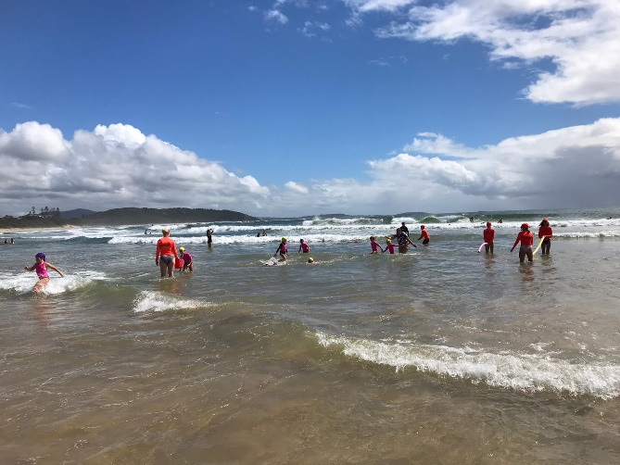

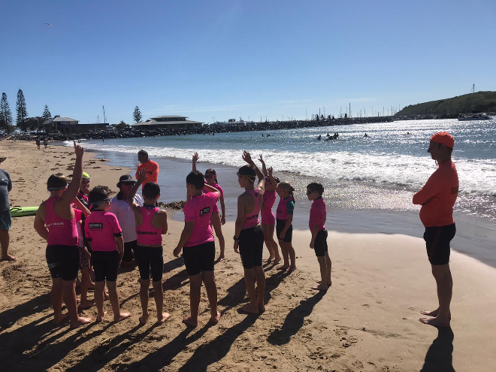 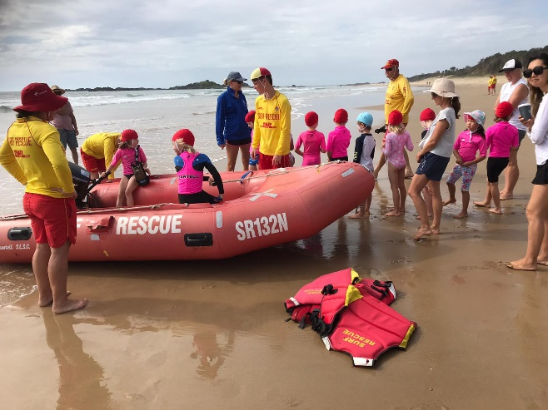

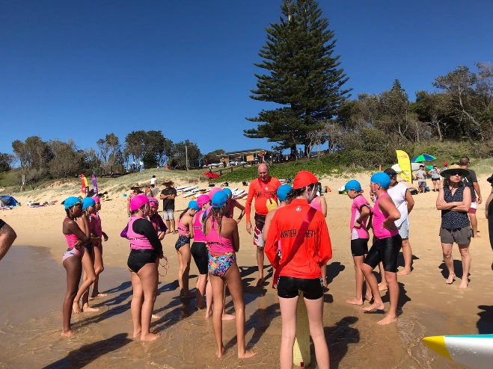 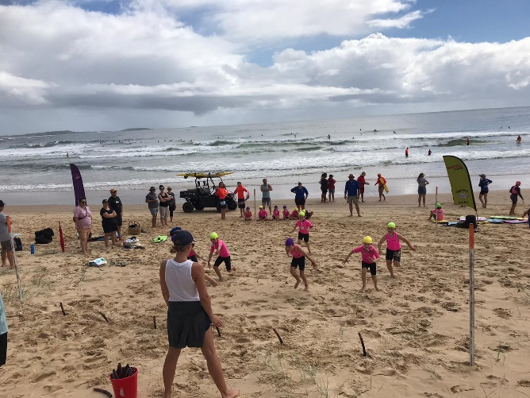

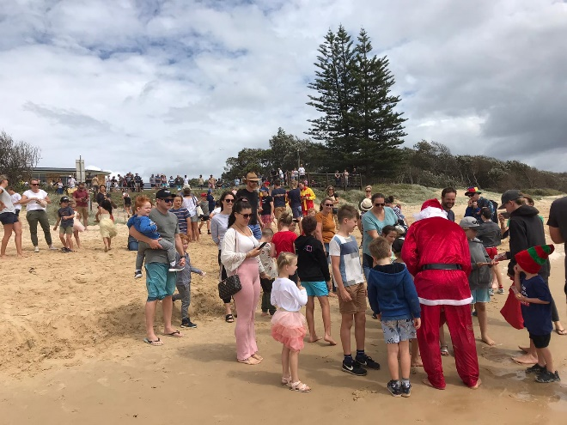 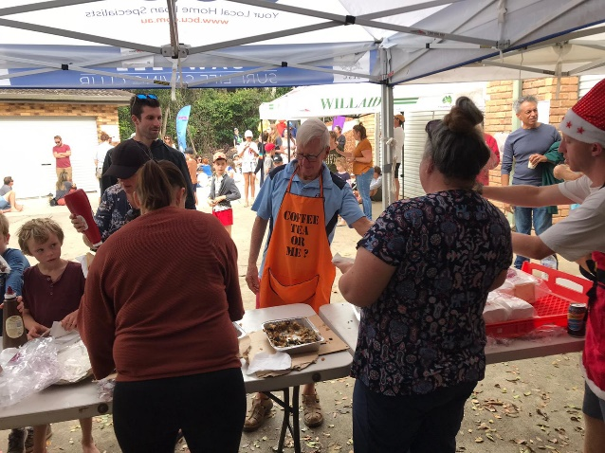

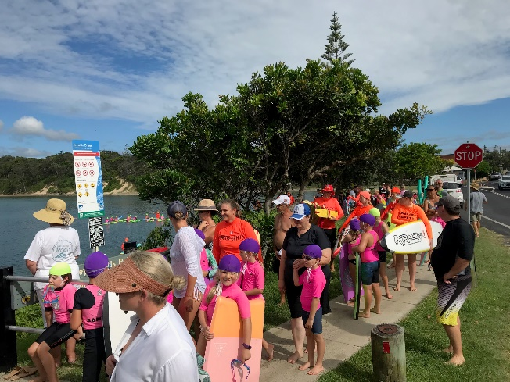 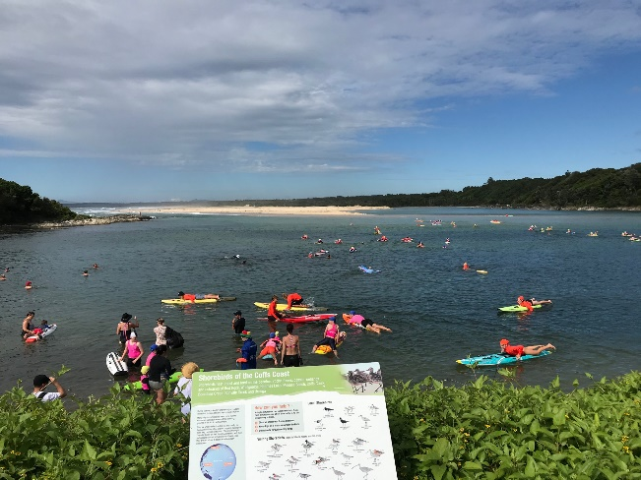

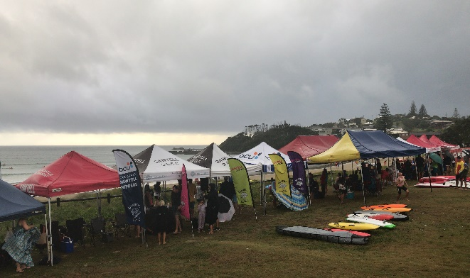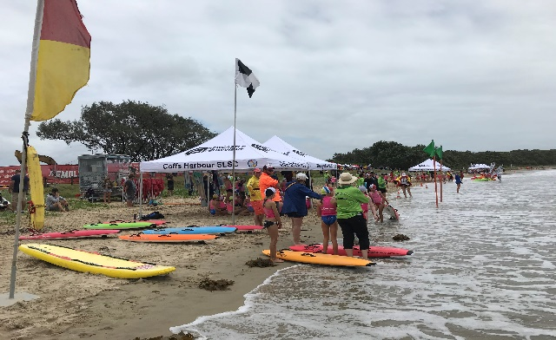

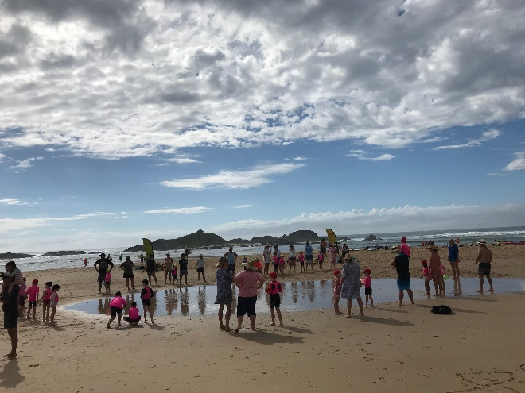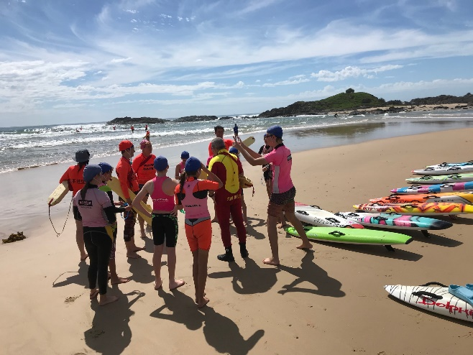

**Treasurers Annual Report 2020/2021 – Junior Activities Sub Committee**

Firstly, I would like to say that it has been a pleasure to be part of the Junior Committee and would like to thank all those involved for your support and commitment this season

We are extremely fortunate that we had a season. In the off season the committee were concerned we were not going to have a season due to Covid and all the restrictions in place at the time. We were concerned that our Nipper member numbers would be down, but this season saw an increase. SLSNSW provided a one off Covid relief payment to allow clubs to reduce membership fees for the 20/21 Season. We had 3 x branch Carnivals and 11 x Nippers compete at Junior State Age Titles in Water and Sand events.

The Surf Life Saving year is 1st May 2020 to 30th April 2021, the information provided today is based on 1st May 2020 to 28th Feb 2021. Sawtell Juniors opened the season with a bank balance of **$28,000.19** and a carryover of one term Deposit of **$10,000**, giving a cash total of: **$38,000.19**.

**Financial activities during the 2020/2021 Junior Season:**

The primary income received is through memberships, followed by sale of club clothing, donations and sponsorship. Our Hooded Sawtell Towels from the previous season proved to be popular among Nippers this season. RJK Optometry signed a 3-year sponsorship deal with Sawtell Nippers for club polo shirts, t-shirts and muscle-t’s. These items of clothing proved popular among the club members with the muscle-t’s and t-shirts selling out within the first few weeks.

We received 4 x Kracka Fiberglass Nipper short boards from the Insurance payout last season.

The club received continuing sponsorship from First National Real Estate for our Age Managers Shirts and Beach Operations Shirt. I would like to welcome the following sponsors to our club which we are in the process of purchasing 3 long fiberglass boards and 2 nipper foam boards for next season

* HQ Concrete
* Bakers Delight
* Split Espresso
* Cutlers Tyre Power Toormina

I would like to acknowledge and thank The Sawtell Ladies Golf Club who donated $250 to our Nippers program allowing for the purchase of flags/batons that will be used on the flag pit and sprint track at Nippers on Sunday next season.

I would like to thank Bakers Delight, Sawtell Boutique Butchery and Sawtell RSL Club for their ongoing support of our club. These businesses supply the bread, sausages and ice we use at our BBQ’s. Other expenditure includes: Capitation fees to SLSNSW and Branch, Nipper Caps, Hi Vis Rashies, Water Safety rashies, U14 SRC training course, repair and maintenance of nipper equipment, trailer maintenance/registration, BBQ and end of season awards and gifts.

As at 28th February 2021, the JASC’s working account has a closing balance of **$32,011.32** with outstanding costs for End of Season Gifts, Awards and BBQ (costs TBA).

Term Deposits are as follows:

* $10,000 – matures 19th August 2021.
* Interest received for the 20/21 Season was $125.14

**Giving a cash total of: $42,011.32.** This places the JASC in a strong financial position for the coming season.

The overarching club contributes to the financial success of the juniors by supporting and providing a solid financial platform for which the committee can work from.

Once again, I would like to thank our JASC committee, The Senior Committee and all of our sponsors and families who support our club

Joanne O’Leary

JASC Treasurer

14 March 2021